* Week 1
  + Course1: Classification and Object Detection Intro

Pass

* + Course2: Segmentation Intro

Semantic segmentation: same class -> one segment

Instance segmentation: …

* + Course3: Transfer Learning

Freeze the weights

With ResNet50:

CIFAR 10 dataset

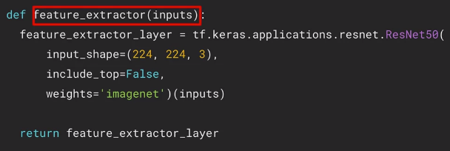 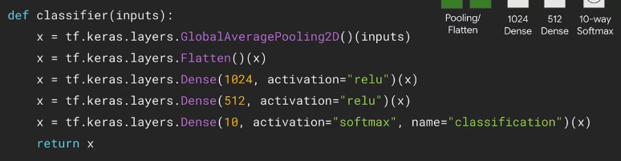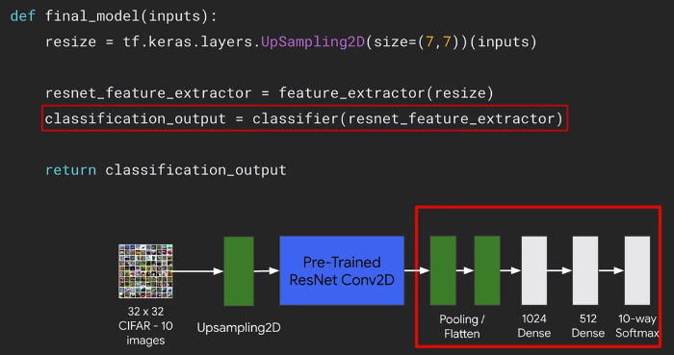

* + Course4: Object Localization

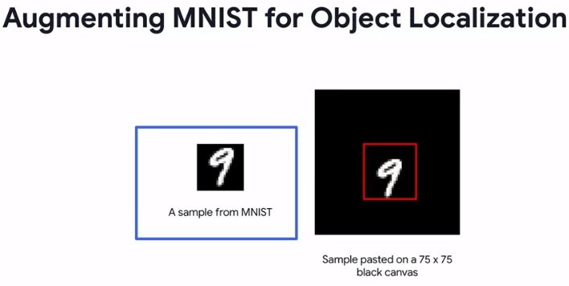

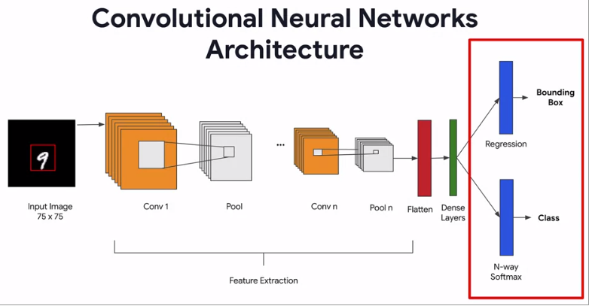

Evaluation:

